Lab number: 6

Title: Practically demonstrate various disk scheduling algorithms (FCFS, SSTF, SCAN, CSCAN, LOOK, CLOOK)

Objective:
To implement and compare the following disk scheduling algorithms using C programs and calculate their total and average head movement:
    - FCFS (First Come First Served)
    - SSTF (Shortest Seek Time First)
    - SCAN (Elevator Algorithm)
    - CSCAN (Circular SCAN)
    - LOOK (LOOK Algorithm)
    - CLOOK (Circular LOOK)

Programming Language: C

IDE/Platform: DEV C+

Theory:
Disk scheduling decides the order in which pending disk input/output requests are served. In a hard disk, the read/write head moves between cylinders to reach the requested data. A suitable scheduling algorithm can reduce head movement and improve access time.

Head Movement
Head movement is the absolute difference between the current cylinder and the next cylinder visited. Total head movement is the sum of these distances along the complete head path.
Head movement = |Next cylinder - Current cylinder|
Average head movement = Total head movement / Number of requests
Movement is measured in cylinders. It is used to compare the algorithms; actual seek time also depends on the disk hardware.

Disk Scheduling Algorithms
- FCFS (First Come First Served)
Requests are served in the order in which they arrive. The head moves from the current position to each request in the original queue.
Advantages: Simple to understand and implement; requests are not starved.
Disadvantages: May produce large head movement when consecutive requests are far apart.

SSTF (Shortest Seek Time First)
The pending request nearest to the current head position is served next. The nearest request is selected again after every movement.
Advantages: Often reduces head movement compared with FCFS.
Disadvantages: Distant requests may starve if nearer requests keep arriving.

SCAN (Elevator Algorithm)
The head moves in one direction and serves requests along the way. If requests remain on the other side, it reaches the disk boundary, reverses direction, and serves them.
Advantages: Provides regular service in both directions.
Disadvantages: Moving to a disk boundary can add unnecessary distance.

CSCAN (Circular SCAN)
The head serves requests in one direction. If requests remain behind it, it reaches the end of the disk, returns to the opposite end without serving requests during the return, and continues in the same direction.
Advantages: Provides more uniform waiting times under continuing request arrivals.
Disadvantages: The return between disk boundaries adds head movement.

LOOK (LOOK Algorithm)
LOOK works like SCAN, but the head reverses the last pending request in its direction instead of going to the disk boundary.
Advantages: Avoids unnecessary movement to disk boundaries.
Disadvantages: A request behind the current sweep must wait for the reversal.

CLOOK (Circular LOOK)
CLOOK works like CSCAN, but the head goes only as far as the last pending request. It then returns directly to the first pending request at the other side and continues in the same direction.
Advantages: Avoids boundary travel and serves requests in a circular order.
Disadvantages: The circular return still adds head movement.

Implementation

Question 1.) Perform FCFS Disk Scheduling Algorithm. Algorithm:
- Start and read the request queue and initial head position.
- Set total head movement to zero.
- Visit each request in its arrival order.
- Add the distance moved and update the head position.
- Display the head path, total movement, and average movement.
- Stop.

Source Code:
#include <stdio.h> #include <stdlib.h> #define MAX 100
#define DISK_SIZE 200
void moveHead(int next, int *head, int *total) {
*total += abs(next - *head);
*head = next;
printf(" -> %d", next);
}
int main(void) {
int request[MAX], n, head, total = 0; printf("Enter number of requests: ");
if (scanf("%d", &n) != 1 || n < 1 || n > MAX) return 1;
printf("Enter request queue: "); for (int i = 0; i < n; i++) {
if (scanf("%d", &request[i]) != 1 ||
request[i] < 0 || request[i] >= DISK_SIZE) return 1;
}
printf("Enter initial head position: "); if (scanf("%d", &head) != 1 ||
head < 0 || head >= DISK_SIZE) return 1;
printf("Head path: %d", head); for (int i = 0; i < n; i++)

moveHead(request[i], &head, &total);
printf("\nTotal head movement = %d cylinders\n", total); printf("Average head movement = %.2f cylinders\n",
(double)total / n); return 0;
}

Question 2.) Perform SSTF Disk Scheduling Algorithm. Algorithm:
- Start and read the request queue and initial head position.
- Mark all requests as unvisited and set total movement to zero.
- Find the nearest unvisited request to the current head.
- Serve it, mark it visited, and update the movement and head.
- Repeat until all requests are served.
- Display the results and stop.

Source Code:
#include <stdio.h> #include <stdlib.h> #define MAX 100
#define DISK_SIZE 200
void moveHead(int next, int *head, int *total) {
*total += abs(next - *head);
*head = next;
printf(" -> %d", next);
}
int main(void) {
int request[MAX], n, head, total = 0; printf("Enter number of requests: ");
if (scanf("%d", &n) != 1 || n < 1 || n > MAX) return 1;
printf("Enter request queue: "); for (int i = 0; i < n; i++) {
if (scanf("%d", &request[i]) != 1 ||
request[i] < 0 || request[i] >= DISK_SIZE) return 1;
}
printf("Enter initial head position: "); if (scanf("%d", &head) != 1 ||
head < 0 || head >= DISK_SIZE) return 1;
int visited[MAX] = {0}; printf("Head path: %d", head);
for (int count = 0; count < n; count++) { int nearest = -1;

int minDistance = DISK_SIZE; for (int i = 0; i < n; i++) {
int distance = abs(request[i] - head);
if (!visited[i] && distance < minDistance) { minDistance = distance;
nearest = i;
}
}
visited[nearest] = 1; moveHead(request[nearest], &head, &total);
}
printf("\nTotal head movement = %d cylinders\n", total); printf("Average head movement = %.2f cylinders\n",
(double)total / n); return 0;
}

Question 3.) Perform SCAN Disk Scheduling Algorithm. Algorithm:
- Start, read the inputs, and sort the queue in ascending order.
- Serve requests at or above the initial head in ascending order.
- If lower requests remain, move to cylinder 199.
- Reverse and serve the lower requests in descending order.
- Calculate total and average head movement.
- Display the results and stop.

Source Code:
#include <stdio.h> #include <stdlib.h> #define MAX 100
#define DISK_SIZE 200
void moveHead(int next, int *head, int *total) {
*total += abs(next - *head);
*head = next;
printf(" -> %d", next);
}
int main(void) {
int request[MAX], n, head, total = 0; printf("Enter number of requests: ");
if (scanf("%d", &n) != 1 || n < 1 || n > MAX) return 1;
printf("Enter request queue: "); for (int i = 0; i < n; i++) {
if (scanf("%d", &request[i]) != 1 ||
request[i] < 0 || request[i] >= DISK_SIZE)

return 1;
}
printf("Enter initial head position: "); if (scanf("%d", &head) != 1 ||
head < 0 || head >= DISK_SIZE) return 1;
/* Sort the requests in ascending order. */ for (int i = 0; i < n - 1; i++) {
for (int j = i + 1; j < n; j++) { if (request[i] > request[j]) {
int temp = request[i]; request[i] = request[j]; request[j] = temp;
}
}
}
int split = 0;
while (split < n && request[split] < head) split++;
printf("Head path: %d", head);
/* First move towards higher cylinder numbers. */ for (int i = split; i < n; i++)
moveHead(request[i], &head, &total); if (split > 0) {
/* Reach the upper boundary before reversing. */ moveHead(DISK_SIZE - 1, &head, &total);
for (int i = split - 1; i >= 0; i--) moveHead(request[i], &head, &total);
}
printf("\nTotal head movement = %d cylinders\n", total); printf("Average head movement = %.2f cylinders\n",
(double)total / n); return 0;
}

Question 4.) Perform CSCAN Disk Scheduling Algorithm. Algorithm:
- Start, read the inputs, and sort the queue in ascending order.
- Serve requests at or above the initial head in ascending order.
- If lower requests remain, move to cylinder 199 and return to 0.
- Count the return movement, then serve lower requests in ascending order.
- Calculate total and average head movement.
- Display the results and stop.

Source Code:
#include <stdio.h>
#include <stdlib.h>
#define MAX 100
#define DISK_SIZE 200

void moveHead(int next, int *head, int *total) {
*total += abs(next - *head);
*head = next;
printf(" -> %d", next);
}
int main(void) {
int request[MAX], n, head, total = 0;
printf("Enter number of requests: ");
if (scanf("%d", &n) != 1 || n < 1 || n > MAX)
return 1;
printf("Enter request queue: ");
for (int i = 0; i < n; i++) {
if (scanf("%d", &request[i]) != 1 ||
request[i] < 0 || request[i] >= DISK_SIZE)
return 1;
}
printf("Enter initial head position: ");
if (scanf("%d", &head) != 1 ||
head < 0 || head >= DISK_SIZE)
return 1;
for (int i = 0; i < n - 1; i++) {
for (int j = i + 1; j < n; j++) {
if (request[i] > request[j]) {
int temp = request[i];
request[i] = request[j];
request[j] = temp;
}
}
}
int split = 0;
while (split < n && request[split] < head)
split++;
printf("Head path: %d", head);
for (int i = split; i < n; i++)
moveHead(request[i], &head, &total);
if (split > 0) {
if (head != DISK_SIZE - 1)
moveHead(DISK_SIZE - 1, &head, &total);
moveHead(0, &head, &total);
for (int i = 0; i < split; i++)
moveHead(request[i], &head, &total);
}
printf("\nTotal head movement = %d cylinders\n", total);
printf("Average head movement = %.2f cylinders\n",
(double)total / n);

return 0;
}

Question 5.) Perform LOOK Disk Scheduling Algorithm. Algorithm:
- Start, read the inputs, and sort the queue in ascending order.
- Serve requests at or above the initial head in ascending order.
- Reverse at the last request reached, without visiting the disk end.
- Serve the lower requests in descending order.
- Calculate total and average head movement.
- Display the results and stop.

Source Code:
#include <stdio.h> #include <stdlib.h> #define MAX 100
#define DISK_SIZE 200
void moveHead(int next, int *head, int *total) {
*total += abs(next - *head);
*head = next;
printf(" -> %d", next);
}
int main(void) {
int request[MAX], n, head, total = 0; printf("Enter number of requests: ");
if (scanf("%d", &n) != 1 || n < 1 || n > MAX) return 1;
printf("Enter request queue: "); for (int i = 0; i < n; i++) {
if (scanf("%d", &request[i]) != 1 ||
request[i] < 0 || request[i] >= DISK_SIZE) return 1;
}
printf("Enter initial head position: "); if (scanf("%d", &head) != 1 ||
head < 0 || head >= DISK_SIZE) return 1;
/* Sort the requests in ascending order. */ for (int i = 0; i < n - 1; i++) {
for (int j = i + 1; j < n; j++) { if (request[i] > request[j]) {
int temp = request[i]; request[i] = request[j]; request[j] = temp;
}
}
}
int split = 0;

while (split < n && request[split] < head) split++;
printf("Head path: %d", head);
/* First move towards higher cylinder numbers. */ for (int i = split; i < n; i++)
moveHead(request[i], &head, &total);
/* Reverse at the last request, not the disk end. */ for (int i = split - 1; i >= 0; i--)
moveHead(request[i], &head, &total);
printf("\nTotal head movement = %d cylinders\n", total); printf("Average head movement = %.2f cylinders\n",
(double)total / n); return 0;
}

Question 6.) Perform CLOOK Disk Scheduling Algorithm. Algorithm:
- Start, read the inputs, and sort the queue in ascending order.
- Serve requests at or above the initial head in ascending order.
- If lower requests remain, return directly to the smallest request.
- Count this return, then serve remaining lower requests in ascending order.
- Calculate total and average head movement.
- Display the results and stop.

Source Code:
#include <stdio.h> #include <stdlib.h> #define MAX 100
#define DISK_SIZE 200
void moveHead(int next, int *head, int *total) {
*total += abs(next - *head);
*head = next;
printf(" -> %d", next);
}
int main(void) {
int request[MAX], n, head, total = 0; printf("Enter number of requests: ");
if (scanf("%d", &n) != 1 || n < 1 || n > MAX) return 1;
printf("Enter request queue: "); for (int i = 0; i < n; i++) {
if (scanf("%d", &request[i]) != 1 ||
request[i] < 0 || request[i] >= DISK_SIZE) return 1;
}

printf("Enter initial head position: "); if (scanf("%d", &head) != 1 ||
head < 0 || head >= DISK_SIZE) return 1;
/* Sort the requests in ascending order. */ for (int i = 0; i < n - 1; i++) {
for (int j = i + 1; j < n; j++) { if (request[i] > request[j]) {
int temp = request[i]; request[i] = request[j]; request[j] = temp;
}
}
}
int split = 0;
while (split < n && request[split] < head) split++;
printf("Head path: %d", head);
/* First move towards higher cylinder numbers. */ for (int i = split; i < n; i++)
moveHead(request[i], &head, &total);
/* The first lower request also counts the wrap. */ for (int i = 0; i < split; i++)
moveHead(request[i], &head, &total);
printf("\nTotal head movement = %d cylinders\n", total); printf("Average head movement = %.2f cylinders\n",
(double)total / n); return 0;
}

OUTPUT:

Output: FCFS
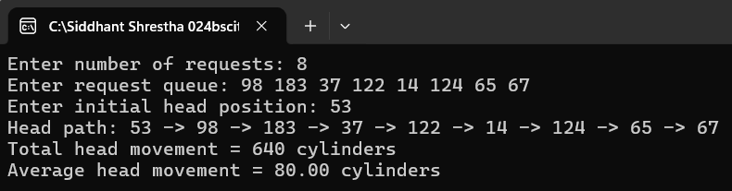

Output: SSTF
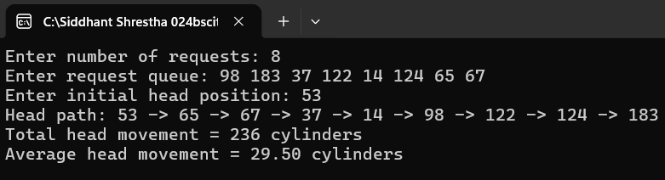

Output: SCAN
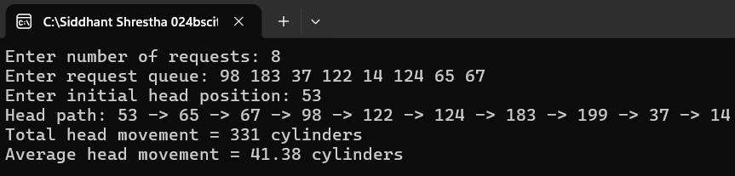

Output: CSCAN
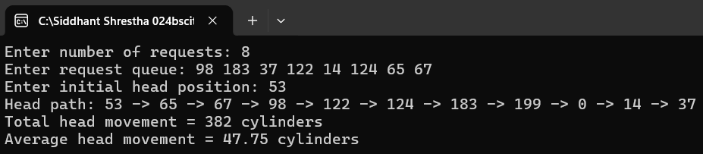

Output: LOOK
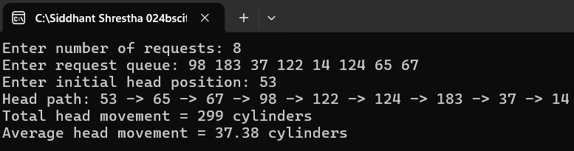

  - Output: CLOOK

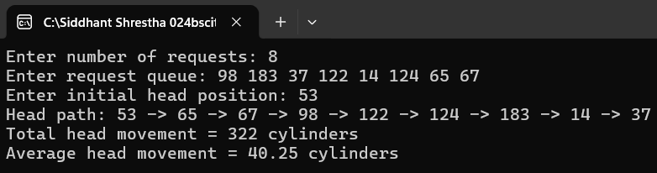

Discussion:
FCFS services requests strictly in arrival order, which is simple and fair but produces the largest total head movement (640) since the arm swings back and forth across the disk without regard to distance. SSTF greatly reduces head movement (236) by always choosing the nearest request but can starve requests that lie far from a cluster of nearby activity. SCAN and LOOK reduce erratic movement by sweeping in one direction before reversing; LOOK (299) improves on SCAN (331) by not travelling all the way to the disk boundary when no request lies beyond the last one serviced. C-SCAN and C-LOOK treat the disk as circular, giving more uniform waiting times for cylinders at both ends at the cost of the "return" jump; C-LOOK (322) is more efficient than C-SCAN (382) for the same reason LOOK improves on SCAN, since it avoids travelling to the physical end of the disk.

Conclusion:
FCFS is easy to implement but generally gives the worst performance since it does not consider request locality. SSTF minimizes seek time greedily and performs well for clustered requests but risks starvation. SCAN and C-SCAN provide predictable, more uniform service by sweeping across the disk, with C-SCAN offering fairer wait times for cylinders at the extremes at the cost of the return sweep. LOOK and C-LOOK improve upon SCAN and C-SCAN respectively by avoiding unnecessary travel to the physical ends of the disk when there is no pending request there, making them more efficient in practice. Overall, the choice of disk scheduling algorithm depends on a trade-off between simplicity, fairness across all requests, and minimizing total head movement.

